QUIZ-4 Chapter 10-11-12-13 Part-3

1. The U.S. government

a. forbids the creation of legal impediments to entry into any market.

b. encourages the permanent monopolization of all markets in which the monopolist has technical superiority over potential competitors.

c. intervenes to prevent the monopolization of any market.

d. intervenes to prevent the monopolization of some markets and actively encourages the monopolization of others.

1. Under a tying contract,

a. the price a buyer must pay for a good is tied to the size of his purchase.

b. a customer agrees as a condition of buying a good to purchase one or more additional goods from the same seller.

c. a firm agrees to allow members of its competitors' boards of directors to sit on its board.

d. a firm agrees to pay an intermediary for having arranged a business deal for the firm.

1. In Figure 10-3, the perfectly competitive firm is realizing a

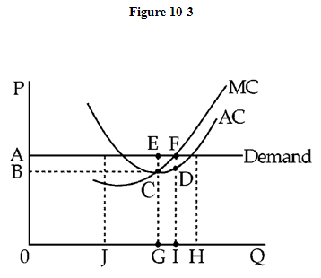

a. profit equal to ABDF.

b. profit equal to ABCE.

c. loss equal to ABCE.

d. loss equal to ABDF.

1. Figure 10-4 shows the industry's supply and demand curves in panel (1) and the cost curves of a firm in the industry in panel (2). At S1, the firm is

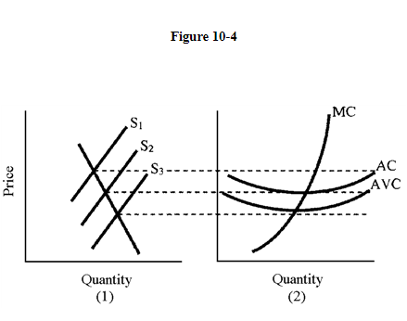

a. preparing to shut down.

b. incurring losses.

c. earning zero economic profits.

d. earning economic profit greater than zero.

1. A monopolist in the radio industry has two radio-making plants. The marginal cost of radio production by Plant A is $4Q (where Q is the number of radios produced) and the marginal cost of radio production by Plant B is always $16. If the demand curve for radios is downward sloping, the monopolist will

a. produce radios at Plant A only as a last resort.

b. never produce radios at Plant A.

c. always produce four times as many radios at Plant B as at A.

d. never produce more than four radios at Plant A.

1. In Figure 11-9, which of the following is true?

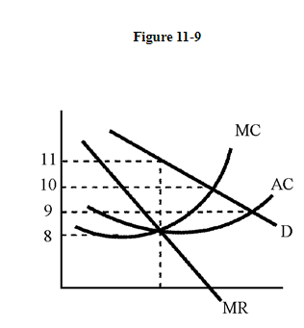

a. MC = MR

b. MU < MC

c. MU > MR

d. MC = P

1. Using the graph in Figure 11-3, the profit-maximizing monopolist will charge a price

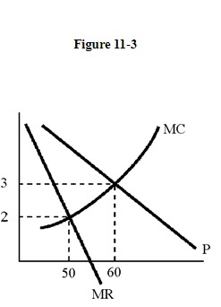

a. of $3.

b. between $2 and $3.

c. of $2.

d. of more than $3.

1. A monopoly firm operates with declining marginal cost. If regulators impose marginal cost pricing, the market will

a. become perfectly competitive.

b. be exited by the existing firm if the regulators will let the firm leave the market.

c. remain a monopoly but behave like a perfectly competitive industry.

d. be entered by additional firms but will not necessarily become perfectly competitive.

1. "Rate averaging" is only possible if

a. the firm can choose the level of service it wishes to provide.

b. "cream skimming" is permitted.

c. the firm is protected from price competition and new entry.

d. the firm is protected from losses resulting from unsuccessful innovation.

1. Exhibit 10-1  
     
   A perfectly competitive producer has the following short-run average cost curve and marginal cost curve:  
     
   SR AC = 2Q + 3  
     
   MC = 4Q + 3  
     
   where costs are measured in dollars and Q represents the firm's output in units.

The firm whose short-run cost curves are given in Exhibit 10-1 has a long-run fixed cost of

a. $4.

b. $2.

c. $0.

d. $3.

1. In Figure 10-5, points which lie on the firm's short-run supply curve are

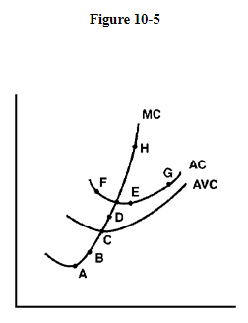

a. A, B, C.

b. C, D, H.

c. F, E, G.

d. A, C, H.

1. In the cigarette industry either R. J. Reynolds or Phillip Morris, for a time, raised prices twice a year by about 50 cents per carton. The other firms in the industry raised their prices by the same amount. Economists call this

a. predatory pricing.

b. a price war.

c. price leadership.

d. sales maximization.

1. Figure 10-4 shows the industry's supply and demand curves in panel (1) and the cost curves of a firm in the industry in panel (2). At S3, the firm is

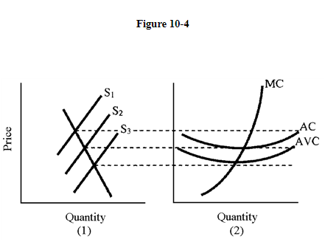

a. going to shut down.

b. earning zero economic profits.

c. earning economic profit greater than zero.

d. incurring losses.

1. The excess capacity theorem implies that

a. consumers would be better off with more standardization of products.

b. monopolistic competition wastes some of society's resources but the elimination of this waste does not necessarily benefit consumers.

c. consumers would be better off if some monopolistically competitive firms left their markets.

d. monopolistic competition benefits society by eliminating excess capacity in production.

1. A home appliances supplier offers substantial discounts to customers if they buy several of the firm's products. When bought together, these items cost considerably less than the sum of the prices of the items if they were bought separately. Which pricing arrangement is being discussed here?

a. Tacit collusion

b. Skimming

c. Bundling

d. Price dealing

1. A regulatory agency concerned with "universal service" must

a. guarantee marginal cost pricing.

b. prevent entry in high-profit markets.

c. prevent cross-subsidization.

d. prevent high profits in all markets.

17. Which of the following acts prohibits directors of one company from sitting on the board of a competitor?

a. Clayton Act

b. Robinson-Pat man Act

c. Sherman Act

d. Federal Trade Commission Act

1. In the short run, the firm in Figure 10-8 will shut down if the price falls below

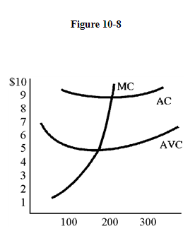

a. $6.

b. $8.

c. $5.

d. $1.

1. Oligopolistic A cuts price in an attempt to enlarge his share of the market. His competitors retaliate with identical price cuts. In this case, in Figure 12-3, oligopolistic A will move from point A to which point?

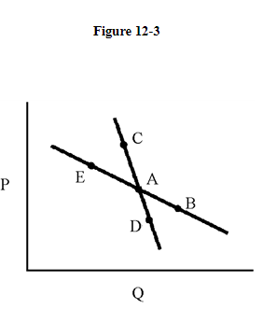

a. C

b. D

c. B

d. E

1. ____ occur when an X percent increase in input use raises output by more than X percent, so that the more the firm produces, the lower its per-unit costs become.

a. Perfect competition

b. Economies of scope

c. Scale economies

d. Product differentiation